MH4U Damage Calculator

Michael Liu

Xiao Han Ji

Alphonse

# Table of Contents

1. Introduction
   1. Project Description
2. Design & Coding
3. Test Runs
4. Issues
5. Team Member Contributions
6. Conclusion
7. References

# Introduction

This website is designed so as to give Casual Monster Hunters within the game Monster Hunter 4 Ultimate the basic knowledge of how much impact each and every one of their attacks will have on the monster they are facing, or at least on average. It should be used as an at-a-glance tool.

### Project Description

The calculator itself will include the ability to select out of 11 different weapons available to the Blade Master class of Hunters and let them pick any of the available in game weapons they are currently using. They are then able to select which hunting abilities they have equipped that are giving the hunters an edge on the monsters they face, and finally, the hunters can select which monsters they are facing at which difficulty level in the game. Following the choices, the hunter will see how much damage their attacks will do on average and how many hits they will need to kill the monster.

The FAQ page will be available for people who don’t quite understand how to use the calculator or are having problems with it to check if their problems have happened before.

The about us page describes who created this site and how to reach us.

The Weapons Guide page will give a basic description of each weapon and have video describing how to use them.

# Design & Coding

Insert html and css here

# Test Runs

At the site’s current stage, the calculator works fully. One bug was found which was a misspelt “break” becoming “breka” causing a minor delay of 5 minutes, otherwise, the javascript worked without a hitch.

How the calculator looks on entry:

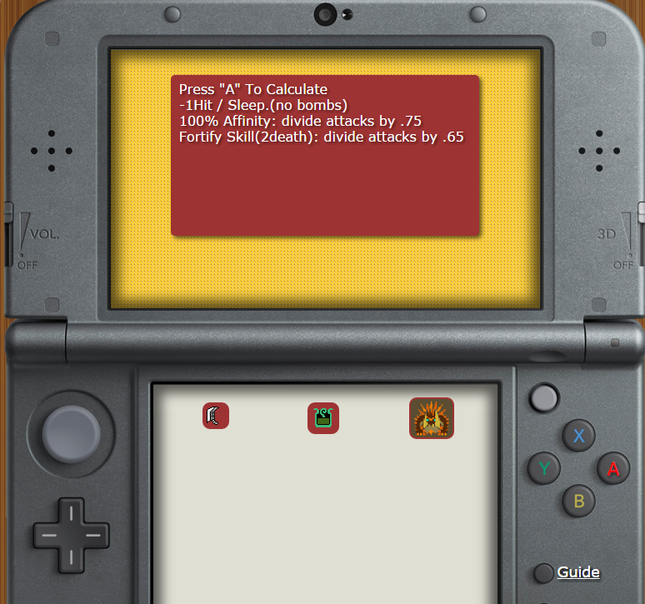

First menu: the weapon selection:

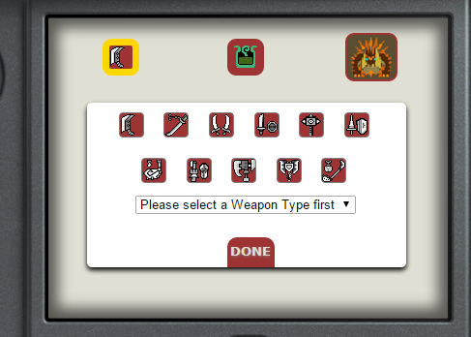

After selecting a weapon type:

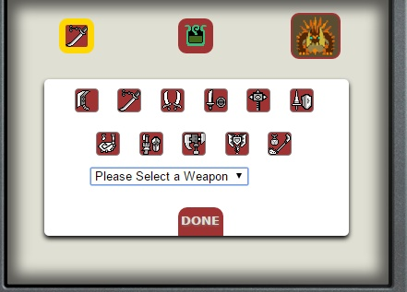

Weapon Selection Menu:

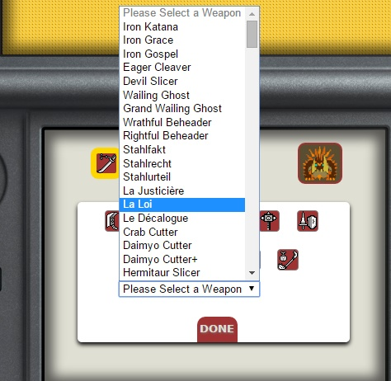

Weapon selected:

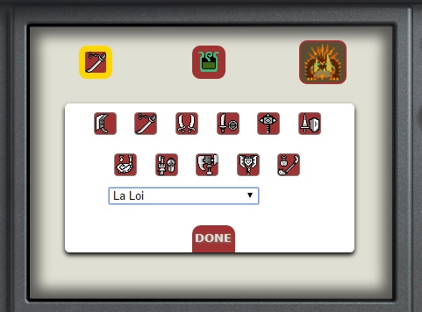

Pressing “Done” button:

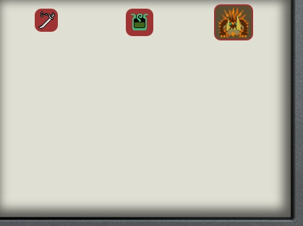

Opening buff Selection (Middle button):

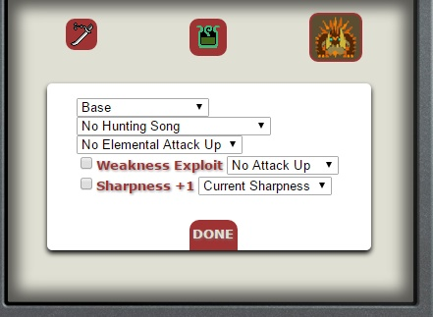

You must select a sharpness, everything else is optional:

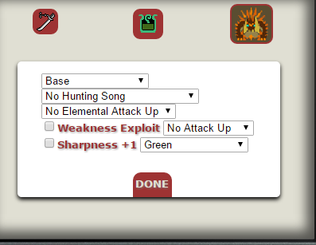

Monster Selection :

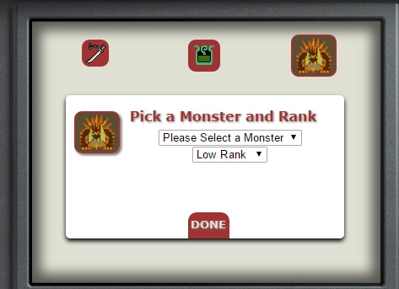

Calculating before selecting a monster:

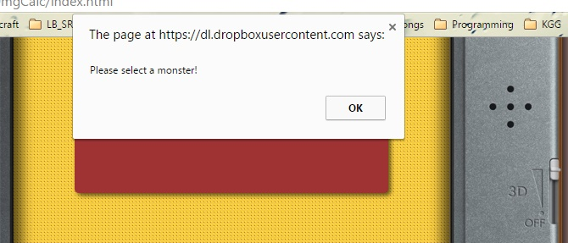

Selecting the monster:

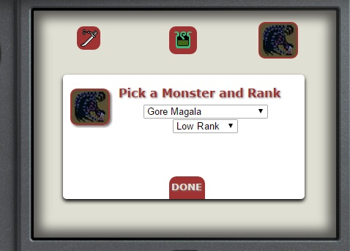

Ready to calculate:

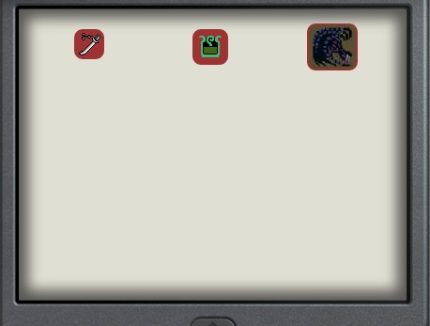

Result of calculations:

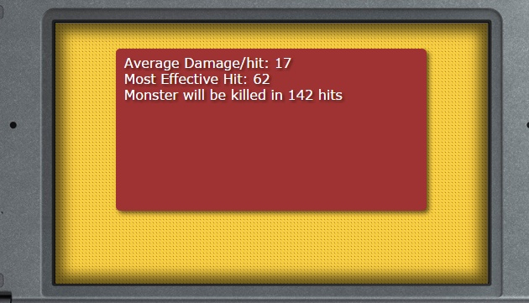

# Issues

* Spending hours trying to figure out why a button isn’t where it should be
* Unknowingly displacing everything with accidental changes in values and make the page look like hell.
* Everyone being busy so not being to use time more efficiently.
* Phone crashing so Alphonse could not be reached for 2 and a half full days over which we worked on the project.

# Conclusion

We were able to complete the main function of the site and we will be filling in on a few missing features testers have been requesting such as a few additional buffs and a clearer navigation screen.

# References

The person who made a better site (<http://minyoung.ch/calculatingpalico/> ) Gave us permission to use their data as data collection otherwise would be a pain.